A Navigation System For Wheelchair Users
(Group 2)
Final Year Project Detailed Plan
By
Mok Ho Ting 3035121322
Tseng Tsz Wa 3035229344

Advised by
Dr. Chim T W

TABLE OF CONTENTS
1.0 INTRODUCTION
1.1 Project Background ----------------------------------------------------------------- 3
1.2 Project Objectives ----------------------------------------------------------------- 3
1.3 Project Scope ----------------------------------------------------------------- 4
1.4 Project Methodology----------------------------------------------------------------- 4

2.0 SYSTEM FUNCTIONS OVERVIEW
2.1 Function List ----------------------------------------------------------------- 6
2.2 Context Diagram ----------------------------------------------------------------- 7

3.0 DEVELOPMENT PLAN
3.1 Technologies Selection Criteria ------------------------------------------------- 9
3.2 System Architecture ----------------------------------------------------------------- 9

4.0 Project Schedule and Milestones--------------------------------------------------- 10

5.0 RISK MANAGEMENT
5.1 Technical and skill acquirement risks------------------------------------------- 11
5.2 Scope and schedule risk------------------------------------------------------------- 12

1. INTRODUCTION

1.1 Project Background
Nowadays, Hong Kong is a technology advanced city. Many Hong Kong citizens use Google Maps or Maps in iOS for finding the paths to destination.
However, those resulting paths in Google Maps or Maps in iOS are for general users only but may not be suitable for the disabled because some paths may contains inaccessibility facilities such as stairs or narrow streets. As a result, this project is a navigation system aiming to the disabled, helping them for finding the paths with accessibility facilities.
The remaining parts of this document will be the following with project objective and project methodology.

1.2 Project Objective
This project will help The University of Hong Kong to develop a navigation system on mobile platform for the wheelchair users in the campus. The wheelchair users can understand where they can go or cannot go. Users can also look for a suitable path between accessibility facilities. If the wheelchair users get lose in the campus or not good at reading map, the system can guide them by simple direction indicator through Augmented Reality technology on their camera. The system would be extended into larger scope even whole Hong Kong instead of the area in HKU.

1.3 Project Scope
This project will work on developing an Android application for navigating the wheelchair user. The application required a map for the navigation system. The navigation system will use some algorithms for searching path by using the map.
Furthermore, users can turn on their camera with Augmented Reality technology to know where the destination is. The scope of this project will first be focused on the campus of the University of Hong Kong. Then it would be expandable to whole Hong Kong area even whole world with the reporting system to provide path searching functions through a user-report system.

1.4 Project Methodology
The navigation system will work on smartphone and be implemented in android platform. Therefore, this project will be implemented by the native development tools such as android studio because the application written by native programming language is the most stable and fast.
The system requires the GPS function of the smartphone to locate the user current point. The user can select a destination point inside the supported area. Dijkstra’s algorithm can be used to calculate the shortest path with accessibility facilities between two places. After the calculation, the system will suggest a shortest path which avoid any inaccessible path in order to help the wheelchair user.
The navigation system really depends on the map which store the geographical data. The map will be built based on Google Map. Since the map provided by Google is not detailed enough to support the navigation system. Extra geographical data is needed to be added into the map. These data will be inputted by the observation of our group.
These data will form a graph as a data structure. Each exit of a location is connected into other exit of a location. The edge between each exit of location is marked whether it is accessible by wheelchair user. As a result, a graph is being created to represent the geography of HKU.
When combining Augmented Reality technology with the map being built, a real time direction indicator can be shown on screen of camera in order to guide user to correct destination/location.

2.0 SYSTEM FUNCTIONS OVERVIEW
2.1 Function List
- Retrieve detailed map
User can retrieve the map from the database. The map is detailed enough so the user can know the geography of the campus and where they can go and where they cannot go. They can also know where is the target location is.
- Check current location
Users can know where they are currently at by the GPS function of their phone and their location will be displayed on the map-form screen.
- Look for a closest toilet
Users can know where the closest toilet is in case they need it.
- Look for a path to target location
Users can select a point in the map and the system will find a shortest and accessible path connected to the selected point from the current location.
- Show the distance
Users can see how far the destination from the current point
- show a direction indicator point to destination point
Users can open their camera to know the destination point by the polar angle with the direction indicator.
- Report inaccessible point
Users can report inaccessible point to help the system to extend the coverage.

2.2 Context Diagram
2.2.1 A detail map showing the exit, lecture hall, lift, toilet of a building.
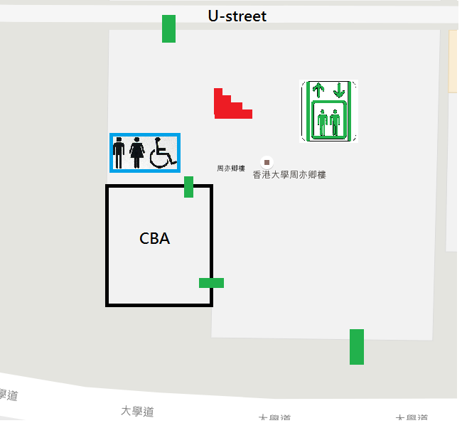
2.2.2 A best path is being determined by the system to the destination point
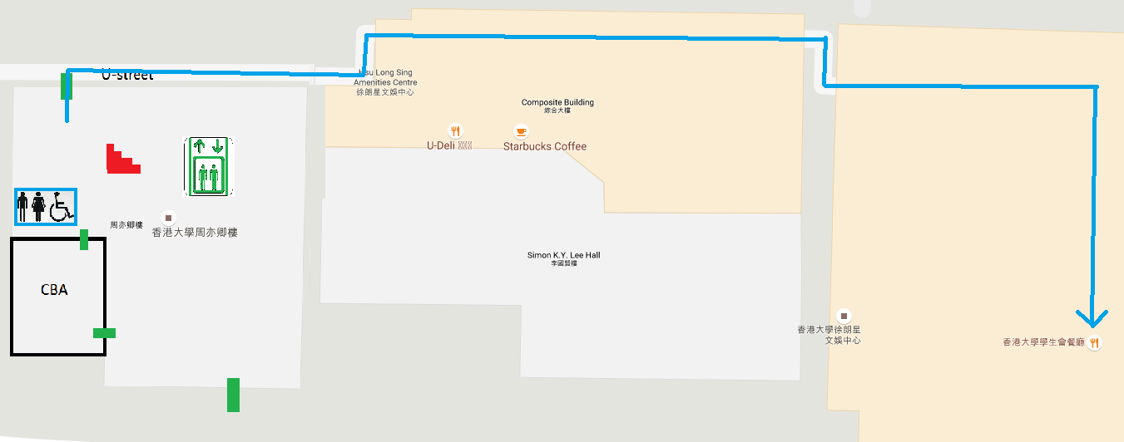

2.2.3 A direction indicator is pointed to the correct direction
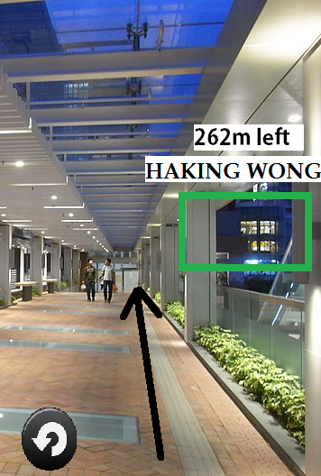

3.0 DEVELOPMENT PLAN
3.1 Technologies Selection Criteria
3.1.1 Global Positioning System (GPS)
GPS is being used because it is available in most of the smartphone nowadays and easy to code. The precision is about 5 meters which meets our requirement. GPS is also more accurate than WIFI in order to implement the navigation system for wheelchair user.
3.1.2 Android SDK Augmented Reality

Wikitude SDK will be used to support 3D tracking, detect surface and assign object onto its surface. It have a trial version which is free and the features needed are available in this version. It is also easy to use.
3.2 System Architecture
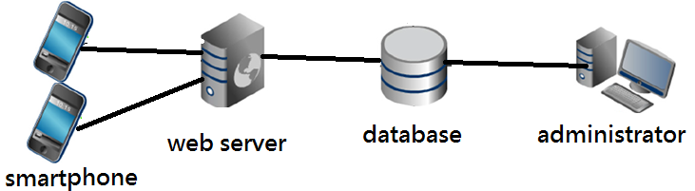
The wheelchair users will use their smartphone to connect the web server through WIFI or 3G/4G network connection. It will request data from the database to form a map which can be shown in smartphone. Users can also use their smartphone to report data through web server to database to improve the map. The administrator can update the map stored in the database.

4.0 Project Schedule and Milestones
September | - project website  - project scheme  - project plan
November | - Project analysis  - Collection of map data
December | - Project management plan
January | - Implementation of path finding algorithm
February | - Implementation of VR/AR technology
March | - Finalized tested implementation
April | - Final presentation
May | - Project exhibition

5.0 RISKMANAGEMENT
5.1 Technical and skill acquirement risks
(i) Consume battery rapidly
The system require users keep turning on the screen which keep consuming battery. Furthermore, The AR technology require users to turn on the camera which consume battery rapidly.
Available solution:
Our group will pay more afford on optimizing the algorithm in order to lower the number of process the smartphone have to proceed. AR mode can also be turned off in case users do not need to in order to save battery level.
(ii) GPS signal might be unstable
GPS signal might be unstable unpredictably if the user is moving too fast or the user reach an uncovered area.
Available solution:
Our group will have more tests on the navigation system after the map is built in order to know how the system being unstable. So, some action can be taken to avoid these unpredictable risk.
(iii) The map built might not be accurate
Some location might be put in an incorrect place in the map because of incorrect input.
Available solution:
A report system will be built for user to report these error to prevent these problem.

(iv) The privacy of geographical data of users can be a concern
The geographical data of users would be collected in order to run the navigation system. The users might think the collection of these data is a concern.
Available solution:
An encryption process can be used to ensure the data collected will not be read by unauthorized people.
5.2 Scope and schedule risk
I. Keeping up with the schedule and progress
As this is the first time for our group to work on a project with such a big scale, our group is worried that we may not keep up the schedule and progress as we have lots of other matters to attend to, such as revising.
II. Making up time for meeting
Our group do not have a same timeslot for attending lesson. It might be difficult to spare time to have a meeting.

Available Solution
We used Google Calendar as a tool to help each other to keep track of each other’s’ timetable. It is much easier to have a meeting. Furthermore, call for a meeting earlier can let us be easier to have a meeting.

