The University of Hong Kong

BEng(ComSc)

Final Year Project 2017

Mixed Reality – MR DrumKit

Wong Ho Sum, Crystal
3035180108

Supervisor: Dr. Y.K. Choi

Table of Contents
Introduction 3
Objective 4
Scope 4
Related Works 5
Aerodrums 5
drummAR 7
Methodology 9
Technologies to be used 9
HoloLens 9
Kinect 10
Unity 10
Approach 11
Feasibility Assessment 12
Risks and challenges 13
Schedule 14
Conclusion 15
References 16

Introduction
Mixed Reality(“MR”) is a technology that merges the virtual and real worlds. It allows the users to see virtual images while seeing the real world. Although it is a rather new technology, one of its most iconic “application” might date back to 15 years ago, where in the movie Minority Report, the main character manipulates data and images floating around him in a futuristic way. Years ago, people have been envisioning how such technologies can help our lives. Today, developers are trying to realise them.

Among musical instruments, a drum set is one of the most difficult instruments that one can own. It is too big and loud. Combining MR and drumming can provide new, convenient experiences.

Objective
This project aims to develop an MR drum set application that allows users to play the drums without needing a real drum set.

Among musical instruments, drum sets are relatively hard to access. Drums are large and usually do not fit into homes of typical Hong Kong people. Sounds produced by playing the drums might also be a disturbance to neighbours. MR DrumKit provides an alternative to physical drum sets. MR DrumKit provides a feasible, accessible and realistic drumming simulation to users.

Scope
The intermediate goal of the project is to develop a prototype application. This prototype includes 2 drumming modes: the standard air drums mode and custom drum kit mode.

In the standard air drums mode, a drum set hologram is projected in front of the user. The user hit the drums with sticks to produce corresponding sounds. Users can also step on the floor to hit the pedals.

In the custom drum kit mode, users can choose different flat surfaces as drum pads. Users hit the selected surfaces to produce corresponding sounds.

The final goal is to develop a more advanced version based on the prototype. More customisation is introduced, such as allowing users to customise the position of different drums in the standard air drums mode or having more choices of drum kits. Music can also be played during the session. A short tutorial will also be included to let beginners learn the basics of drumming.

As the focus of this application is on practicability, this application does not include beautiful graphics. Also, due to time constraints, this application does not provide very precise differentiation on the intensity of forces used to hit the drums.

Related Works

Aerodrums
Figure 1: Components of Aerodrums
Taken from https://keepdrum.de/
Aerodrums is a commercial air-drumming product (Figure 1). It is a software that runs on Mac/PC. The program uses a PlayStation Eye camera (Figure 1, upper right) to track the movement of the Aerodrums sticks (Figure 1, bottom) and foot markers (Figure 1, middle left). The sticks are normal drumsticks with silvery balls attached to the end. The foot markers are also reflective wedges. When setting up, users need to configure the position of the camera and the user. A light source (Figure 1, middle right) is used to emit stable light. Sunglasses (Figure 1, middle) are provided to protect the users’ eyes from the light source.

2

1
Figure 2: (1) Users hit the air to hit the invisible drums. (2) Users can see the position of the sticks to the drums in the computer. The glowing device is the lamp and camera.
Taken from https://www.pcmarket.com.hk/
To play the Aerodrums, users need to hit the space in front of them just like hitting a real drum set (Figure 2, (1)). The program interprets users’ movement relative to the virtual drum set using the PlayStation camera’s high-speed capture capability. Then the program produces the sound of the drum corresponding to the space where the user hit. Users can see the position of the sticks relative to the virtual drum set on the computer screen (Figure 2, (2)).

Aerodrums produces very natural sounds, and its expressiveness is said to be on par with a real drum [1]. It supports 16 levels of elevation of the pedal. It is very delicate and precise that it received praise from professionals and novices alike [2] [3] [4]. It achieved the goal of being a quiet and portable drum kit. It is also very customisable, for instance, the position and the number of drums can be changed according to users’ needs. However, as users cannot see the drums as they play it, they have to adapt to air-drumming when they first use it [3]. Beginners might have to constantly look at the computer screen to know where the drums are. If users can visually see the virtual drums, users can play more smoothly.

drummAR

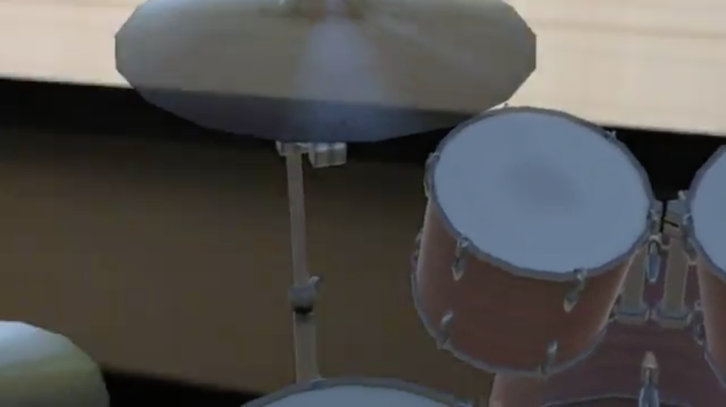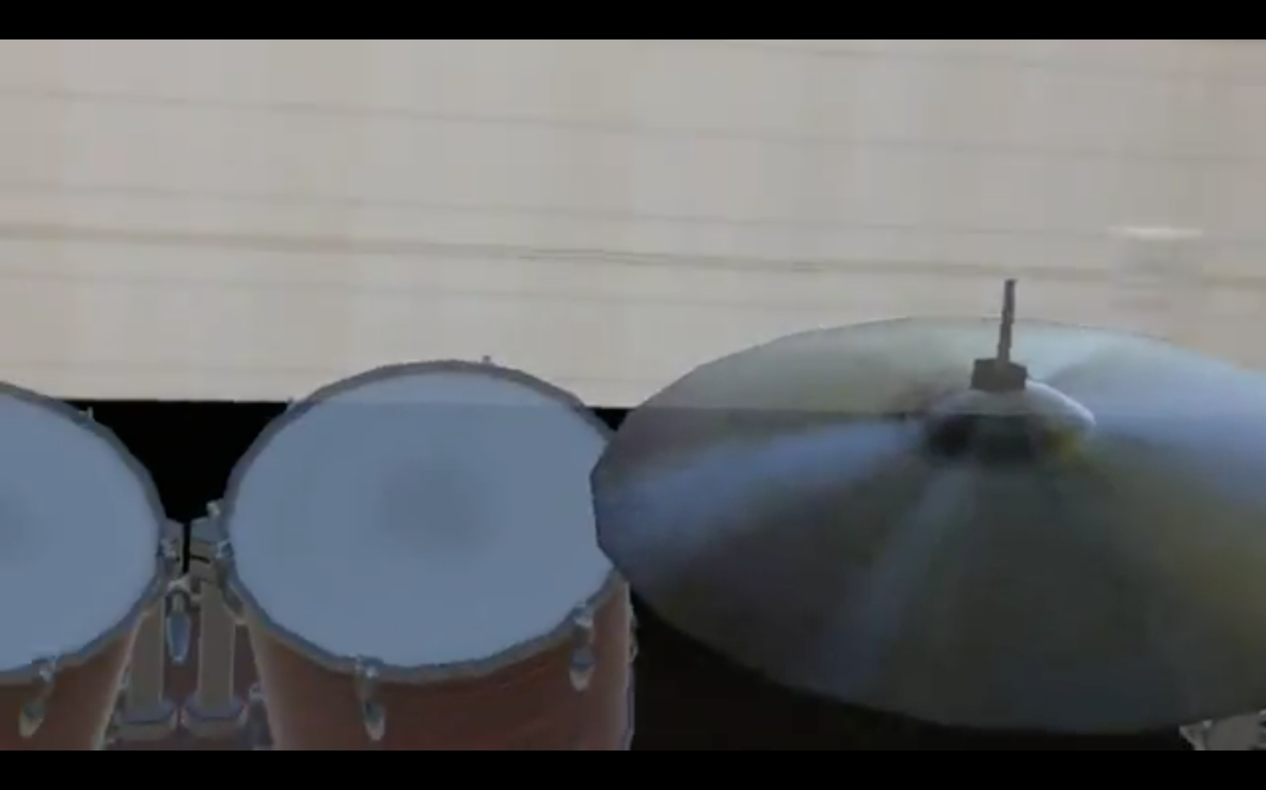
Figure 3: Hologram of a drum kit can be seen through the Hololens.
Taken from https://devpost.com/software/drummar
drummAR is a Hololens application that lets users play with a holographic drum set. This application was developed by a couple of college students in at the Microsoft HoloHack 2017 in 2 days. Vuforia and Unity were used. As seen in Figure 3, users wearing the Hololens can see a virtual 3D drum set in front of them.

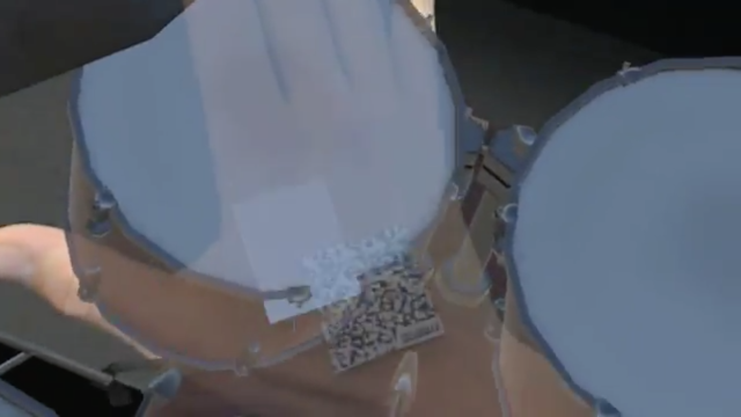

2

1
Figure 4: (1) The marker on the back of the hand is used as a target for the camera.
(2) The program recognises a "collision" when the marker collides with the drums.
Taken from https://devpost.com/software/drummar
To play the drums, the user first has to stick a special marker sticker on the back of the user’s hand (Figure 4 (1)). The marker is used by the Hololens camera to capture the movement of the hand. When the hand touches a virtual drum, the program produces the corresponding drum sound (Figure 4 (2)).

This application is quite primitive. The program can only recognise 1 marker at one time, so users can only use one hand to interact with the drums. The recognition done by Hololens is also kind of slow. Users cannot move the hand around very rapidly. Also, the application did not deal with pedals. Some of the drums cannot be accessed by users.

However, the objective of this application is rather close to that of this project. If peripherals like the Kinect, a motion capturing device, is employed to capture user movements, more complicated movement can be supported. The motion of the feet can also be captured.

Methodology

Technologies to be used

HoloLens

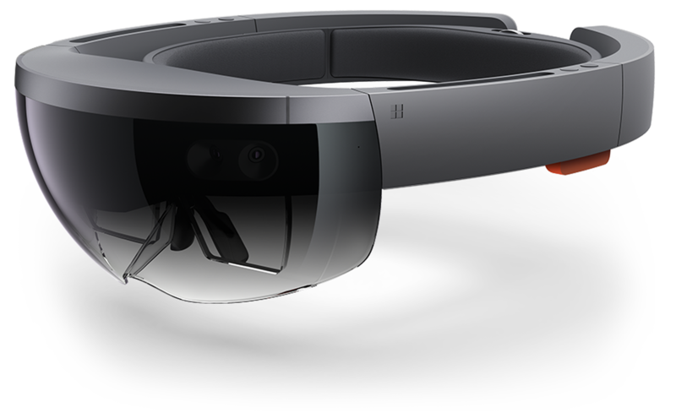
Figure 5: The Microsoft HoloLens
Taken from https://www.windowscentral.com/
The Microsoft HoloLens (“Hololens”) (Figure 5) is used in this application. The Hololens is a standalone MR headset. Hololens lets users see 3D holograms projected over the real environment (Figure 6). Computer chips, memory and batteries are fitted in the headset, so there is no need to tether it to a computer. A pair of translucent screens allows users to see virtual images and the real environment at the same time. Sensor units comprised of depth cameras and light sensors are positioned on the two sides of the headset to sense the environment and the user’s movements. Accelerometers, gyroscopes and magnetometers are used to detect the movement of the head. 3D images are rendered differently according to the location of the head to the environment, which gives the user a sense that the image is a real 3D object. Microphones are used to taking commands using voice control. The speakers do not block out the environment and they support stereo sounds. [1] [2] [3]

The Hololens runs on Windows 10. Unity is used to develop applications.

Figure 6: Concept image of the Hololens in action
Taken from https://www.wareable.com/

Kinect
Figure 7: Kinect for Xbox One
Taken from https://www.xbox.com/

The Kinect is a motion sensing device developed by Microsoft (Figure 3). It is first released as an add-on for the Xbox series game consoles. Users can control and interact with the consoles with gestures and voice commands. The technology Structured light is used to compute a depth map, and machine learning to analyse body position [4].

Unity
Unity is a cross-platform game engine that is mainly used for game development. Unity supports the development of 2D and 3D graphics. C# is mainly used for scripting. Unity is the recommended engine for creating 3D apps for Hololens [5].

Approach
In this project, the MR technology is used instead of VR. This is because that it would be more convenient for users if they could also see the real environment. The users can see their hands and legs. Users can also read music scores while playing.

Hololens is chosen for this project because it is the only MR equipment that does not require any tethering to a computer. Users might have body and head movements when playing the drums. They can feel freer to move along with the rhythm.

Hololens’ scanning capability will also be utilised to detect the user’s environment. The Hololens will scan for the floor and flat surfaces. The Hololens will scan for the floor to project the drum set on the floor in the standard air drums mode. The Hololens will scan for flat surfaces for the user to choose as different drums in the custom drum kit mode.

Hololens’ scanning capability will also be used to detect user gesture input. Users will be able to set some options using hand gestures, such as setting the volume and switching between drum sets.

Kinect will be used to capture users’ movements. Kinect is also developed by Microsoft, so it has good compatibility with the Hololens. Kinect’s full body motion capture capability will be used for tracking user’s hands and feet movement.

The application will be developed in Unity in C#. Unity is suitable because 3D graphics will be used in this project. Unity also has a comprehensive asset store, which offers ready-to-use 3D drum kit models.

Feasibility Assessment
Although several applications with similar ideas have already been developed, many of them utilise other types of technologies. Aerodrums used a camera to capture drumming motions rather precisely, and that camera has similar motion-capturing capabilities to the Kinect. Drumming motions, including feet movements, are capturable by such camera devices. The drummAR application shows that interactive holographic drums are possible. There are also some other projects that use Kinect for invisible-air-drumming [10] [11]. This project is close to the above projects and should be feasible.

Risks and challenges
Limitation of Hololens’ computational power
As the Hololens is a standalone headwear, all its calculations are done within itself. As its size, weight and heat also have to be balanced, the computational power of the Hololens is sacrificed. The Hololens is not as powerful as other computer-tethered headgear. Complicated calculations should be avoided. The Hololens’ scanner is also not very real-time. There is some time lag between movement of a hand and a recognition of the movement. Such limitations should be taken into consideration when developing the application.

Limitation of Kinect’s tracking on high-speed movement
The Kinect does support high-speed tracking as implemented in commercial game software. However, in most of the Kinect drumming application demos developed by students that were used as a reference in the research phase of this project, it can be seen that rapid movement could not be supported [10] [11]. Students could only hit the drums when movement is slow. The reason could be that detection of high-speed movement requires advanced concepts, possibly mathematical ones such as smoothing. Due to time and knowledge constraints, the tracking ability of this project might not be at commercial level.

Compatibility between the Hololens and Kinect
Combining use of the Hololens and the Kinect started in around last year [12]. It is still a developing technology. Not a lot of Hololens applications that uses Kinect can be found. Although the two devices came from the same company and should be compatible, there might still be some problems or practical issues when developing. Help and fixes might not as accessible.

Communication between the Hololens and Kinect
Communication between these two devices is done wirelessly. It is now hard to foretell the quantity and quality of data in communications. Wireless connections might not be fast or stable enough. During development, it should be kept in mind that volume and frequency of transmissions should be within communication capabilities of devices.

Spatial restrictions of Kinect
Users should remain detectable for the Kinect. They should not be too far or near to the camera. Their gesture should remain detectable throughout runtime. Also, in the custom drum kit mode, users can place the drums according to their wish. However, the locations should not be out of Kinect’s detectable space. Restrictions should be issued when users place the drums.

Schedule

Sept | Get familiar with Unity
Oct 1 | Project plan  Project website
Oct | Collect user requirements  Analysis and Design program
Nov - Dec | Achieving the intermediate goal  Development with Hololens (w/ emulator)  - Displaying with Hololens  - Scanning with Hololens  Development with Kinect  - Motion capturing with Kinect
Jan - Feb | Implementation of communication between devices  Implementation of two drum modes
Jan 8-12 | First Presentation
Jan 21 | Intermediate Report
Feb - Mar | Achieving the final goal  Fine tuning  - Improving user interface  - Adding customisation features  - Sounds and graphics enhancement
Apr | Testing and optimisation
Apr 16-20 | Final Presentation
Apr 15 | Final Report
May 2 | Project Exhibition

Conclusion
This project aims to develop a mixed reality drumming application to provide an alternative to large and noisy physical drum sets. The Hololens and Kinect will be used. Practicability will be focused on.
References

[1] | Aerodrums, “Aerodrums,” [Online]. Available: http://aerodrums.com/aerodrums-product-page/. [Accessed 29 September 2017].
[2] | D. Lewis, “Aerodrums Review,” 2 July 2015. [Online]. Available: https://www.youtube.com/watch?v=8EFFcy_vaQk. [Accessed 29 September 2017].
[3] | K. Schiano, “Aerodrums - A Virtual Drum Kit!!!,” 17 December 2016. [Online]. Available: https://www.youtube.com/watch?v=wgptHLBI0e4. [Accessed 29 September 2017].
[4] | JPhoenix19, “In case you were wondering... (An honest review of Aerodrums),” 30 November 2014. [Online]. Available: http://www.sevenstring.org/threads/in-case-you-were-wondering-an-honest-review-of-aerodrums.284473/. [Accessed 29 September 2017].
[5] | S. Colaner, “What's Inside Microsoft's HoloLens And How It Works,” tom's Hardware, 23 August 2016. [Online]. Available: http://www.tomshardware.com/news/microsoft-hololens-components-hpu-28nm,32546.html. [Accessed 27 September 2017].
[6] | E. Limer, “How Microsoft's HoloLens Works Its Holographic Magic,” Popular Mechanics, 1 May 2015. [Online]. Available: http://www.popularmechanics.com/technology/gadgets/a15324/how-microsofts-hololens-works/. [Accessed 27 September 2017].
[7] | A. Dachis, “What's the Difference Between HoloLens, Meta & Magic Leap?,” Next Reality, 15 October 2016. [Online]. Available: https://mixed.reality.news/news/whats-difference-between-hololens-meta-magic-leap-0171361/. [Accessed 27 September 2017].
[8] | J. MacCormick, “How does the Kinect work?,” 2011. [Online]. Available: https://users.dickinson.edu/~jmac/selected-talks/kinect.pdf. [Accessed 27 September 2017].
[9] | Microsoft, “Development overview,” [Online]. Available: https://developer.microsoft.com/en-us/windows/mixed-reality/development_overview. [Accessed 28 September 2017].
[10] | A. Sharma, “Air-Drumming with Kinect,” 15 September 2013. [Online]. Available: https://www.youtube.com/watch?v=jMNOCa_jz-o. [Accessed 1 October 2017].
[11] | D. Herrero, “Air Drums with Kinect and Unity,” 7 April 2016. [Online]. Available: https://www.youtube.com/watch?v=oZHwNFxANfs. [Accessed 1 October 2017].
[12] | J. Callaham, “Merging the Microsoft HoloLens and Kinect could get us one step closer to the holodeck,” 28 June 2016. [Online]. Available: https://www.windowscentral.com/merging-microsoft-hololens-kinect-could-create-holodeck. [Accessed 1 October 2017].
[13] aerodrumming, “Drummers trying Aerodrums for the first time at NAMM 2014,” YouTube, 11-Feb-2014. [Online]. Available: https://www.youtube.com/watch?v=FAprpyGdgYk. [Accessed: 28-Sep-2017].
[14] D. Lewis, “Aerodrums Review,” YouTube, 02-Jul-2015. [Online]. Available: https://www.youtube.com/watch?v=8EFFcy_vaQk. [Accessed: 28-Sep-2017].
[15] Aerodrums. [Online]. Available: http://aerodrums.com/aerodrums-product-page/. [Accessed: 28-Sep-2017].
[16] Lawrluor, “lawrluor/drummAR,” GitHub, 06-Aug-2017. [Online]. Available: https://github.com/lawrluor/drummAR. [Accessed: 28-Sep-2017].

