Hotel Accommodation
The conference hotels are located in close proximity to the conference venue at the Chinese University of Hong Kong. Limited rooms with special conference rates are available for the delegates to “The 21st Annual International Conference on Research in Computational Molecular Biology (RECOMB)” to book now. Hotel reservation should be made with the hotels directly through the reservation forms provided by the hotels.

Hyatt Regency Hong Kong, Sha Tin
Located next to the Cheng Yu Tung Building and the University MTR station, the hotel offers direct access to Tsim Sha Tsui, Hong Kong Island, Lo Wu and Lok Ma Chau at Shenzhen, via the MTR. It is only a 5 minutes ride from Hong Kong Science Park and Sha Tin Racecourse, and 30 minutes by taxi from Hong Kong International Airport, with numerous Sha Tin attractions and landmarks nearby.
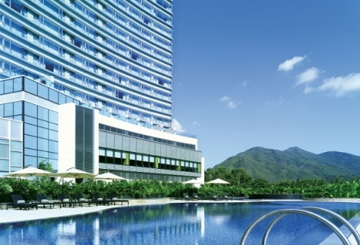 | 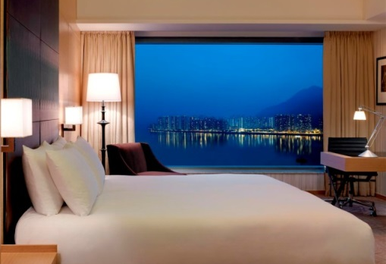

The travelling time between the hotel and the conference venue is about 5 to 10 minutes walk.
Address: 18 Chak Cheung Street, Shatin, New Territories, Hong Kong (View Map)
Tel: (852) 3723 1234
Fax: (852) 3723 1235
Email: hongkong.shatin@hyatt.com
Website: www.hongkong.shatin.hyatt.com
Reservation: Online reservation (links)
Reservation Deadline: 12 April 2017

Royal Park Hotel
The hotel is conveniently located in the heart of Sha Tin. Adjacent to the Sha Tin MTR station, the hotel is around 10 minutes ride by MTR from CUHK and 45 minutes from the Hong Kong International Airport. It is embraced by various famous tourist attractions and shopping malls, such as Hong Kong Heritage Museum, Sha Tin Racecourse and New Town Plaza.
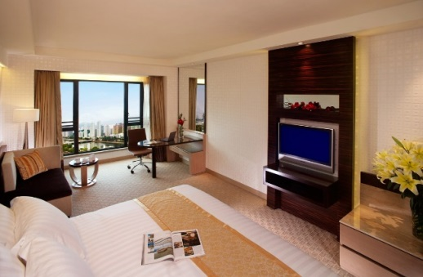

The travelling time is about 10 minutes ride from Sha Tin station to University station by MTR.
Address: 8 Pak Hok Ting Street, Shatin, New Territories, Hong Kong (View Map)
Tel: (852) 2601 2111
Fax: (852) 2601 3666
Email: inquiry@royalpark.com.hk
Website: www.royalpark.com.hk
Reservation: Reservation form (download link)
Reservation Deadline: 3 April 2017

Courtyard by Marriot Hong Kong Sha Tin
Courtyard by Marriott Hong Kong Sha Tin is the second addition to the Courtyard brand of Marriott International in Hong Kong. Located next to business, commercial and cultural attractions in Sha Tin, the hotel is conveniently accessible with a mere 5-minute walk to the Shek Mun MTR station (Ma On Shan Line).
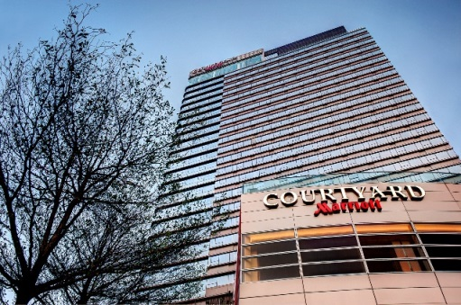 | 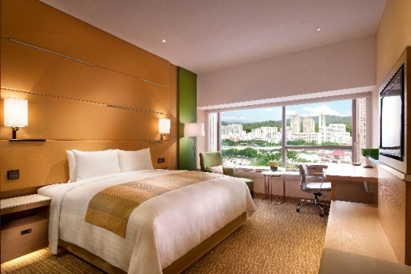

The travelling time is about 10 minutes ride from hotel to University station by hotel shuttle bus or taxi.
Address: 1 On Ping Street, Sha Tin New Territories (View Map)
Tel: (852) 3940 8888
Fax: (852) 3940 8828
Email: cy.hkgst.sm@courtyard.com
Website: http://www.marriott.com/hotels/travel/hkgst-courtyard-hong-kong-sha-tin/
Reservation: Reservation form (download link)
Reservation Deadline: 3 April 2017

Regal Riverside Hotel
Overlooking the picturesque Shing Mun River in Sha Tin, Regal Riverside Hotel offers a relaxing environment and attentive services from the hustle and bustle of Hong Kong. Guests can easily access to Shenzhen by a quick MTR ride, or connect to all shopping, entertainment and business districts in Hong Kong via other public transports right on the hotel’s doorstep.
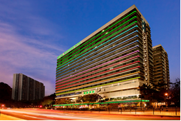 | 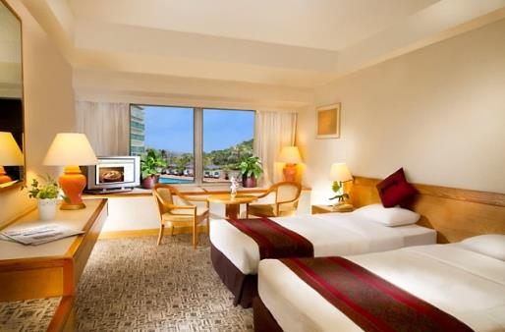

The travelling time is about 10 minutes ride from hotel to University station by taxi.
Address: 34-36 Tai Chung Kiu Road, Shatin, Hong Kong (View Map)
Tel: (852) 2649 7878
Fax: (852) 2637 4748
Email: info@riverside.regalhotel.com
Website: http://www.regalhotel.com/regal-riverside-hotel
Reservation: Reservation form (download link)
Reservation Deadline: 18 April 2017

