Department of Computer Science

The University of Hong Kong

Final Year Project 13004

Project Plan

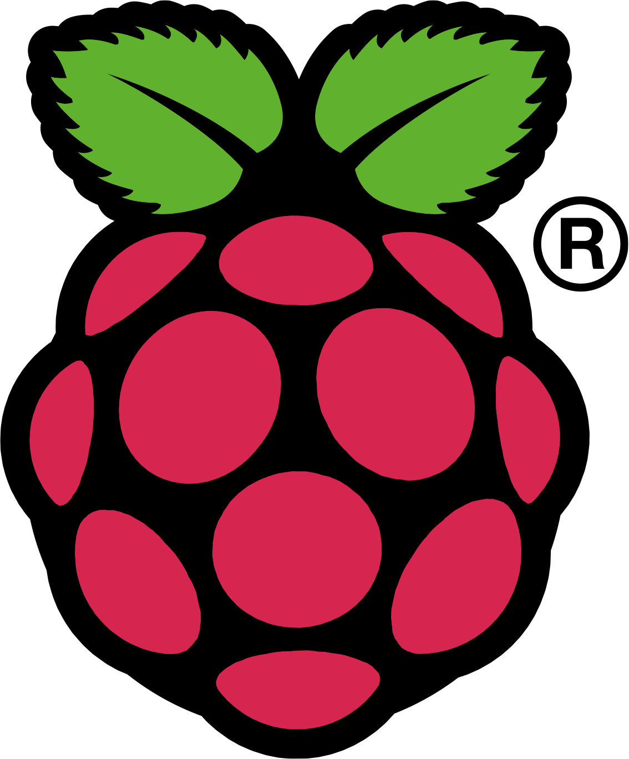

Raspberry Pi

H.264 Video Decoder

Shaurya Srivastava
UID: 2011556846
Bachelor of Engineering in Computer Science
The University of Hong Kong

Supervisor:

Dr. Ronal H.Y. Chung
B.Eng, MPhil (HKU); PhD (HKU); M.IEEE

Table of Contents

- INTRODUCTION 3
1.1 Project Objectives 3
1.2 Project Deliverables 3
1.4 Reference Materials 3
- PROJECT IMPLEMENTATION 4
2.1 Strategy 4
2.2 Hardware and Software 4
2.3 Project Phases 4
- TECHNICAL PROCESS 5
3.1 Methods, Tools and Techniques 5
3.2 Project Support Functions 5
- SCHEDULE AND BUDGET 6
4.1 Resource Requirement 6
4.2 Budget and resource allocation 6
4.3 Schedule 6-8

1. Introduction
The demand for video content is increasing day by day, be it in the cyberspace or in the field of broadcasting. And it’s not just any video; it’s High Definition (HD) video.
These video files being large in size need compression and decompression, a job that is handled by a video codec.

H.264 is one such video codec, which enables video compression. According to Wikipedia, “H.264 is one of the most commonly used formats for recording, compression and distribution of high definition video.”
This project will implement encoding and decoding of a video stream using the h.264 codec.

Being a student of Computer Science, I have had experience in programming but never got a chance to develop on hardware such as the Raspberry Pi. The idea of working with real world hardware, and knowing that this technology is used worldwide in Blu-ray disks as well as by website like YouTube, Vimeo and iTunes Store, motivated me further to take up this project.

1.1 Project Objectives
- Research into video encoding and decoding.
- Learn about video streams.
- Get familiar with Raspberry Pi.
- Learn about h.264 video codec.
- Develop an h.264 video decoder using Raspberry Pi.

1.2 Project Deliverables
The deliverables of this project is a video decoder, which uses h.264 codec running on Raspberry Pi.

1.3 Reference Materials

2. Project Implementation

2.1 Strategy
During the implementation phase, my strategy is to first implement a video decoder on Raspberry Pi that is not connected to the Internet. The video content will be stored on the SD card and decoded from there itself. In the next phase, I will start decoding videos from an Internet stream.

2.2 Hardware and Software
- The hardware i.e. Raspberry Pi, is available in the market and will be accommodated in the project budget. The programs will be written in C language on Raspbian OS, which is an open source Linux based OS.
- The coding will be done on Raspbian OS installed on an emulator.
- The hardware will be used during the test phase and demo.

2.2 Project Phases
There will be four main phases of the implementation:

Phase I
In the first phase, the decoder will decompress video from the SD card in the system. The deliverables of first phase is a video decoder that can decode videos from hard disk or memory cards.

Phase II
In the second phase, the decoder will decompress videos directly from the Internet. The deliverables of the second phase is a video decoder that can decode videos form an Internet stream.

Phase III
The third phase is dedicated to preliminary testing, bug fixing and enhancement of the video decoder.

Phase IV.
The fourth phase is dedicated to final testing of the implemented video decoder using videos of different resolutions.

3. Technical Process

3.1 Tools and Techniques

The video decoder will be made on a single board computer system called the Raspberry Pi using h.264 codec. It is based on an arm processor and runs Raspbian OS.

The Pi comes equipped with SD card slot that acts as the hard drive of the system, two USB ports, Ethernet port and HDMI slot.

The programming language used in this project will be C and the license of h.264 codec is to be bought separately.

To test the implementation an HD LCD TV with an HDMI input will be required.

3.2 Project Support Functions

4. Budget and Schedule

4.1 Resource Requirement
The resources required for this project are:
- Raspberry Pi
- SD card.
- USB Keyboard and mouse.
- HD LCD TV.
- H.264 video codec.
- A PC with QEMI emulator installed.

4.2 Budget
The total budget for this project is HK$ 1000.

Hardware budget:
Name Qty. Price
1. Raspberry Pi 1 HK$350
2. SD card(8 GB) 1 HK$40
3 USB hub 1 HK$40

Software budget:
1. H.264 codec license 1 HK$200

4.3 Schedule

September 2013
- Get hardware ready for the project.
- Buy accessories.
- Install RaspianOS.
- Project Plan and Project website.

October 2013
- Week 1
- Write first few basic programs and get familiar with the OS.
- Week2
- Research about codes and streams. Buy required codecs.
- Week 3
- Learn basic of video encoding and decoding.
- Week 4
- Write a basic video decoding program.

November 2013
- Week 1
- Start Phase I of implementation.
- Week2
- Phase I.
- Week 3
- Phase I.
- Week 4
- Finish Phase I.

December 2013
- Week 1
- Semester Exams.
- Week2
- Semester Exams.
- Week 3
- Start Phase II of implementation.
- Week 4
- Phase II.

January 2014
- Week 1
- Partially Finish Phase II.
- Week 2
- First Presentation.
- Week 3
- Deliver preliminary implementation and interim report.
- Week 4
- Work on Phase II.

February 2014
- Week 1
- Finish Phase II.
- Week 2
- Start Phase III.
- Week 3
- Preliminary testing after Phase III.
- Week 4
- Start on Phase III.

March 2014
- Week 1
- Work on Phase III.
- Week 2
- Finish Phase III.
- Week 3
- Complete Phase IV.
- Week 4
- Start with Final Report.

April 2014
- Week 1
- Work on Final Report.
- Week 2
- Work on Final Report.
- Week 3
- Deliver tested implementation and final report.
- Week 4
- Final Presentation.

