AI Student Advisor Detailed Project Plan

Members:
Kwong Brian (3035279571)
Chung Man Kit, Pieter (3035262530)
Hui Chi Kit, Kit (3035280269)

Content

Project Background
Project Objective
Project Methodology
Application Functions
Project Schedule and Milestones

Project Background

Students start a brand new journey after entering university. Nevertheless, this exciting and challenging adventure always comes up with different kinds of difficulties. We found that students are always facing various kinds of academic and career difficulties in the university. During year 1, students often have questions about course registration and major selection. Afterwards, students may have questions about exchange programmes, internship, and job seeking. Students always feel helpless and want to seek advice when facing these kinds of difficulties. Therefore, we come up with an idea.

Although there is the academic advising teacher, some students may feel shy to seek for help and the teacher may not be able to answer students immediately. To solve this problem, we decided to develop the AI Student Advisor. It is an AI ChatBot which can answer students’ questions regarding academic or career problems immediately. It can provide the best advice to students by searching from the database, so that students may have a better approach to solve their difficulties.

Project Objectives

AI Student Advisor is an AI ChatBot which students can ask questions about academic and career problems and interact with it. There are several objectives of developing the AI Student Advisor.

First of all, we aim to provide an immediate response platform for students. AI Student Advisor can provide solutions after receiving students' questions immediately, so that students can make the best decisions in the shortest time.

Secondly, provide informative solution to students. AI Student Advisor will collect information from previous anonymous transcript and searching from the Internet to provide informative advice to students, so that students can have a better decision.

Last but not least, reduce the burden of the academic advising teacher. Students often ask similar and common questions that maybe time-consuming for the academic advising teacher to answer them one by one. AI student advisor can help to answer those repeating and common questions so as to reduce the burden of the teacher and make the answering process more efficient.

Project Methodology

Identify the user input
The ChatBot should be able to identify the input that using different language or text but referring to the same meaning. As the similar questions can be presented as different texts. For example, “How can I go to KKLeung building from HKU station?” or “HKU station to KKLeung.”. Both text input should lead to a similar result.

To make sure the ChatBot can identify the questions, Keyword analysis API will be used to achieve that. The idea of keyword analysis is to extract the keywords from the sentence, after that the ChatBot will base on the keywords extracted to give corresponding response.

A better scheduler for HKU student
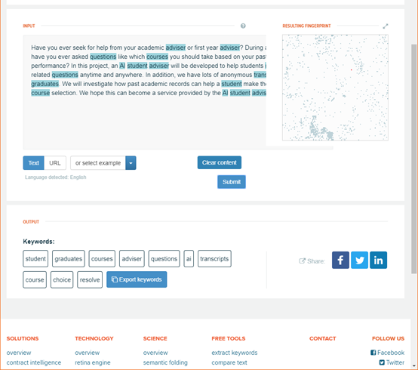
The app has a function that help HKU students to schedule theirs class timetable. A better UI will be provided, students can use the app for the class selection before using hku portal to registration. This function will start at a blank timetable, students can bowser the course information in the sidebar. The key to this UI is that once users add some course into the temporary course list, the blank timetable will update immediately and it will have a pop message to alert users that if any course that added into temporary list is crashed.

On this function, we only need all the course information (include course code, time, venue…), this information can access in HKU website.

Response Part:

Ans by Our team:
For the first few questions, as we do not have enough information in the database, so we will have a form to email the question to our team email, we will then answer the user’s question by emailing back. <form action="mailto:someone@example.com" method="post"

Search from internet:
Question of the user will get by .html <form action="http://www.google.com/search" method="get"> and search in google. In return, a couple of links will provide for the user.

Search from the database:
the keywords and do a matching in the mySQL database to find any other users hv ask similar keywords before. It will find out the keywords of the question, and then the question have tags of those keywords, if match with the searching keywords, it will send the “suggested” answer to the user.

-Identify keywords:
Steps: identifying the keywords, (e.g. different, CS, CE)
formatting these keywords(e.g. Alphabetical order)
Find linking words (and, or, not,)

Project Schedule and Milestones

